[LAB SUBMISSION – 5](https://github.com/shrishtinigam/DSA_Lab/tree/main/Lab_5) <-link

# Meher Shrishti Nigam – 20BRS1193

**CODE FOR DOUBLY LINKED LIST – FOR QUESTIONS 1, 2**

*// DoublyLinkedList.c*

#include <stdio.h>

#include <stdlib.h>

#include <limits.h>

*/\**

*A doubly linked list here is defined by its "start".*

*"start" is a node pointer that points to the first element.*

*Here, start is a proper node with memory allocated to it.*

*Note that start doesn't store any actual data.*

*The next of the start node stores the location of the first element in the doubly linked list.*

*The prev of the start node is NULL and never accessed.*

*The data of the start node is INT_MIN and never accessed.*

*Thus, if we create a doubly linked list "dll", dll->start->next gives us the first element.*

*The first element's prev node is NULL. (Thus, it is not connected to the start node.)*

*"len" stores the number of elements in the linked list. This can be easily calculated,*

*however it is added to make things easier and for illustration. It can be removed.*

*Functions are written independent of len.*

*Functions provided:*

*insertAtStart*

*insertAtEnd*

*insertAtPosition*

*display*

*search*

*deleteAtStart*

*deleteAtEnd*

*deleteAtPosition*

*\*/*

typedef struct Node{

    int data;

    struct Node * prev;

    struct Node * next;

}Node;

typedef struct DoublyLinkedList

{

    Node * start;

    int len;

}DoublyLinkedList;

Node * createNode(int *item*)

{

    Node * temp = (Node *)malloc(sizeof(Node));

    temp->data = *item*;

    temp->next = NULL;

    temp->prev = NULL;

    return temp;

}

DoublyLinkedList * createDoublyLinkedList()

{

    DoublyLinkedList * dll = (DoublyLinkedList *)malloc(sizeof(DoublyLinkedList));

    dll->len = 0;

    dll->start = (Node *)malloc(sizeof(Node));

    dll->start->data = INT_MIN; *// Data in the start node is never to be accessed. If INT_MIN is the data displayed, an error has possibly occured*

    dll->start->next = NULL;

    dll->start->prev = NULL;

    printf("A new doubly linked list was created!\n");

    return dll;

}

*/* Insertion */*

*// Inserts an element at the start of a linked list*

void insertAtStart(DoublyLinkedList * *dll*, int *item*)

{

    Node * newnode = createNode(*item*);

    if(*dll*->start->next != NULL)

    {

        newnode->next = *dll*->start->next;

*dll*->start->next->prev = newnode;

    }

*dll*->start->next = newnode;

    printf("%d was inserted at the start of the doubly linked list!\n", *item*);

*dll*->len++;

}

*// Inserts an element at the end of a doubly linked list*

void insertAtEnd(DoublyLinkedList * *dll*, int *item*)

{

    Node * newnode = createNode(*item*);

    Node * ptr = *dll*->start;

    while(ptr->next != NULL)

        ptr = ptr->next;

    ptr->next = newnode;

    if(ptr != *dll*->start)

        newnode->prev = ptr;

    printf("%d was inserted at the end of the doubly linked list!\n", *item*);

*dll*->len++;

}

*// Inserts an element at a specified position.*

*// Here, position is determined by usual 1-base counting. If position = 5, item will be the fifth element in the linked list*

void insertAtPosition(DoublyLinkedList * *dll*, int *item*, int *position*)

{

    Node * newnode = createNode(*item*);

    Node * ptr = *dll*->start;

    for(int i = 0; i < (*position* - 1); i++)

    {

        if(ptr->next == NULL && i + 1 < *position*)

        {

            printf("Invalid Location\n");

            return;

        }

        ptr = ptr->next;

    }

    if(*position* != 1) *// If adding at beginning then newnode's prev will remain NULL*

        newnode->prev = ptr;

    if(*dll*->start->next != NULL) *// When list is not empty*

    {

        newnode->next = ptr->next;

        if(ptr->next != NULL)

            ptr->next->prev = newnode; *// Skip this if adding at the end*

    }

    ptr->next = newnode;

    printf("%d was inserted at position %d of the doubly linked list!\n", *item*, *position*);

*dll*->len++;

}

*/* Traversal */*

*/* Display function provided for illustrative purposes.*/*

void display(DoublyLinkedList * *dll*)

{

if(*dll*->start->next == NULL)

    {

        printf("Empty Doubly Linked List, nothing to display.\n");

        return;

    }

*// Printing data*

    Node * ptr = *dll*->start->next;

    printf("Start: %d \n", *dll*->start);

    while(ptr != NULL)

    {

        printf("%d       ", ptr->data);

        ptr = ptr->next;

    }

*// Printing the location*

    Node * ptr2 = *dll*->start->next;

    printf("\n%d ", *dll*->start->next);

    while(ptr2 != NULL)

    {

        printf("%d ", ptr2->next);

        ptr2 = ptr2->next;

    }

    printf("\n");

}

*// Returns the 1-base position of the first occurance of data.*

int search(DoublyLinkedList * *dll*, int *item*)

{

    if(*dll*->start->next == NULL)

    {

        printf("Empty Doubly Linked List, nothing to search for.\n");

        return INT_MIN;

    }

    int count = 1;

    Node * ptr = *dll*->start->next;

    while(ptr->data != *item*)

    {

        if(ptr->data != *item* && ptr->next == NULL)

        {

            printf("%d not found in the doubly linked list.\n", *item*);

            return INT_MIN;

        }

        ptr = ptr->next;

        count++;

    }

    printf("%d found at %d position in the doubly linked list.\n", *item*, count);

    return count;

}

*/* Deletion */*

*// Deletion at start*

int deleteAtStart(DoublyLinkedList * *dll*)

{

    if(*dll*->start->next == NULL)

    {

        printf("Doubly Linked List is empty, nothing to delete.\n");

        return INT_MIN;

    }

    Node * ptr = *dll*->start->next;

*dll*->start->next = ptr->next;

    if(ptr->next != NULL)

        ptr->next->prev = NULL;

    int data = ptr->data;

    free(ptr);

    printf("%d was deleted from the start of the doubly linked list.\n", data);

*dll*->len--;

    return data;

}

*// Deletion at end*

int deleteAtEnd(DoublyLinkedList * *dll*)

{

    if(*dll*->start->next == NULL)

    {

        printf("Doubly Linked List is empty, nothing to delete\n");

        return INT_MIN;

    }

    int data;

    Node * ptr = *dll*->start->next;

    while(ptr->next != NULL)

        ptr = ptr->next;

    if(ptr->prev == NULL) *// Only one element is present*

*dll*->start->next = NULL;

    else *// Other cases*

        ptr->prev->next = NULL;

    data = ptr->data;

    free(ptr);

*dll*->len--;

    printf("%d was deleted from the start of the doubly linked list.\n", data);

    return data;

}

*// Deletion of an element at a particular position*

*// Here, position is determined by usual 1-base counting.*

int deleteAtPosition(DoublyLinkedList * *dll*, int *position*)

{

    if(*dll*->start->next == NULL)

    {

        printf("Doubly Linked List is empty, nothing to delete\n");

        return INT_MIN;

    }

    Node * ptr = *dll*->start;

    int data;

    for(int i = 0; i < *position*; i++)

    {

        if(ptr->next == NULL && i < *position*)

        {

            printf("Invalid Location\n");

            return INT_MIN;

        }

        ptr = ptr->next;

    }

    if(ptr->prev == NULL) *// If first element is to be deleted*

*dll*->start->next = ptr->next;

    else

        ptr->prev->next = ptr->next;

    if(ptr->next != NULL)

        ptr->next->prev = ptr->prev;

    data = ptr->data;

    free(ptr);

*dll*->len--;

    printf("%d was deleted from %d position of the doubly linked list.\n", data, *position*);

    return data;

}

void introduction()

{

    printf("~ To display the DLL, enter 1.\n\n");

    printf("INSERTION\n~ To insert an element at the start DLL, enter 2 and the element.\n");

    printf("~ To insert an element at the end of the DLL, enter 3 and the element.\n");

    printf("~ To insert an element at a specific position of the DLL, enter 4, the element and the position.\n\n");

    printf("DELETION\n~ To delete an element from the start DLL, enter 5.\n");

    printf("~ To delete an element from the end of the DLL, enter 6.\n");

    printf("~ To delete an element from a specific position of the DLL, enter 7 and the position.\n");

    printf("\n~ To search for an element, enter 8 and the element.\n\n");

    printf("~ To print this message again, enter 9.\n");

    printf("~ To exit, enter 0.\n\n");

}

int main()

{

    printf("\nWelcome to Doubly Linked List (DLL) Generator!\n\n");

    introduction();

    int x = -1;

    int item, position;

    DoublyLinkedList * dll = createDoublyLinkedList();

    printf("\n");

    while(x != 0)

    {

        scanf("%d", &x);

        switch (x)

        {

            case 0: printf("Exiting... Thank you!\n"); break;

            case 1: display(dll); break;

            case 2: printf("data: "); scanf("%d", &*item*); insertAtStart(dll, item); break;

            case 3: printf("data: "); scanf("%d", &*item*); insertAtEnd(dll, item); break;

            case 4: printf("data: "); scanf("%d", &*item*); printf("position: "); scanf("%d", &*position*); insertAtPosition(dll, item, position); break;

            case 5: deleteAtStart(dll); break;

            case 6: deleteAtEnd(dll); break;

            case 7: printf("position: "); scanf("%d", &*position*); deleteAtPosition(dll, position); break;

            case 8: printf("data to be searched: "); scanf("%d", &*item*); search(dll, item); break;

            case 9: introduction(); break;

            default: printf("Invalid value, try again.\n"); break;

        }

    }

}

**Next Page..**

**The following cases were tested while writing the code for insertAtStart**

1. Insert at start in an empty list
2. Insert at start in a non-empty list

**The following cases were tested while writing the code for insertAtEnd**

1. Insert at end in an empty list
2. Insert at end in a non-empty list

**The following cases were tested while writing the code for insertAtPosition**

1. Insertion in between two elements
2. Insertion at the end in a non-empty list
3. Insert at beginning in a non-empty list
4. Insertion when list is empty and position = 1
5. Insertion when list is empty but position > 1 (invalid case)
6. Insertion when position is too large (invalid)

**The following cases were tested while writing the code for deleteAtStart**

1. Delete at start when list is empty (invalid)
2. Delete at start when list has 1 element
3. Delete at start when list has more than 1 element

**The following cases were tested while writing the code for deleteAtEnd**

1. Delete at end when list is empty (invalid)
2. Delete at end when list has 1 element
3. Delete at end when list has more than 1 element

**The following cases were tested while writing the code for deleteAtPosition**

1. Deletion from empty list (invalid)
2. Deletion in between two elements
3. Deletion at end when list has more than 1 element
4. Deletion at start when list has more than 1 element
5. Deletion when 1 element is present and postion = 1
6. Deletion when 1 element is present but postion > 1 (invalid case).
7. Deletion when position is too large (invalid)

**RUNNING THE DOUBLY LINKED LIST CODE TO SOLVE PROBLEM 1**



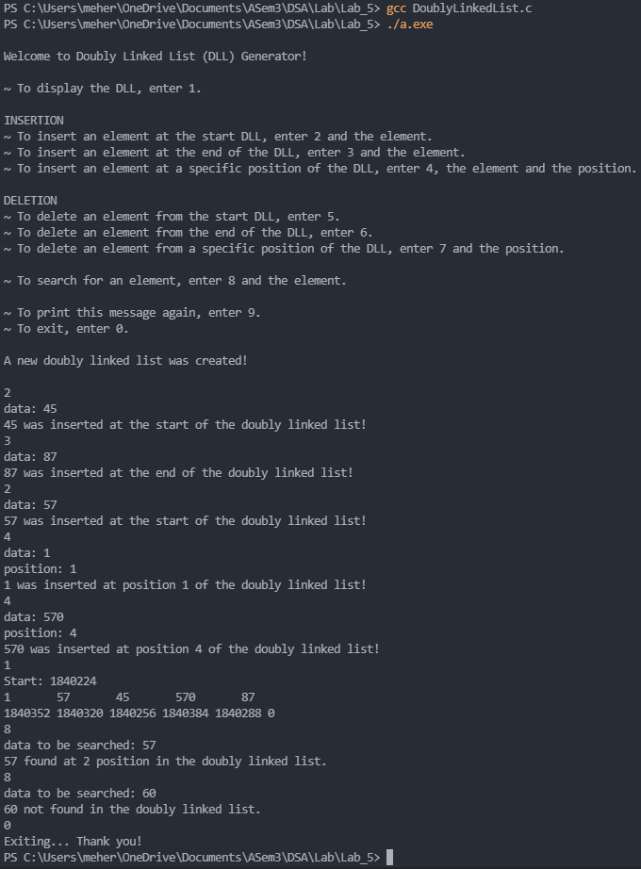

**RUNNING THE DOUBLY LINKED LIST CODE TO SOLVE PROBLEM 2(a)**



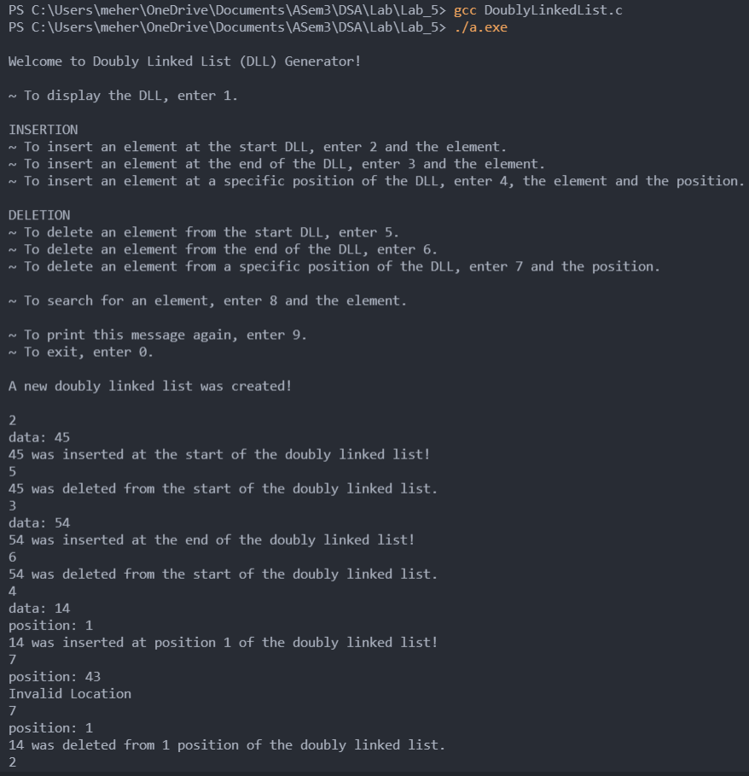

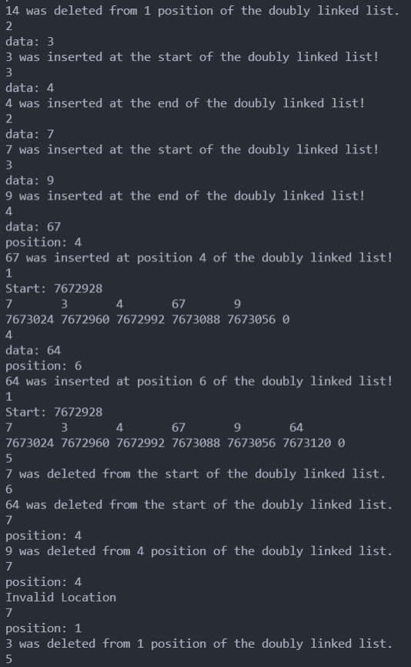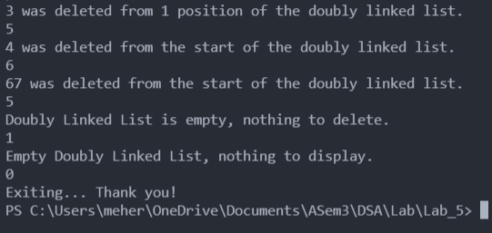

**CODE FOR CIRCULAR DOUBLY LINKED LIST – FOR QUESTION 2**

*// CircularDoublyLinkedList.c*

#include <stdio.h>

#include <stdlib.h>

#include <limits.h>

*/\**

*A circular doubly linked list here is defined by its "start".*

*"start" is a node pointer that points to the first element.*

*Here, start is a proper node with memory allocated to it.*

*Note that start doesn't store any actual data.*

*The next of the start node stores the location of the first element in the doubly linked list.*

*The prev of the start node is NULL and never accessed.*

*The data of the start node is INT_MIN and never accessed.*

*Thus, if we create a circular doubly linked list "dcll", dcll->start->next gives us the first element.*

*The first element's prev node is the address of the last node. (Thus, it is not connected to the start node.)*

*The last elements's next node is the address of the first node. Thus the linked list is circular.*

*"len" stores the number of elements in the linked list. This can be easily calculated,*

*however it is added to make things easier and for illustration. It can be removed.*

*Functions are written independent of len.*

*Functions provided:*

*insertAtStart*

*insertAtEnd*

*insertAtPosition*

*display*

*search*

*deleteAtStart*

*deleteAtEnd*

*deleteAtPosition -> not done*

*\*/*

typedef struct Node{

    int data;

    struct Node * prev;

    struct Node * next;

}Node;

typedef struct CircularDoublyLinkedList

{

    Node * start;

    int len;

}CircularDoublyLinkedList;

Node * createNode(int *item*)

{

    Node * temp = (Node *)malloc(sizeof(Node));

    temp->data = *item*;

    temp->next = NULL;

    temp->prev = NULL;

    return temp;

}

CircularDoublyLinkedList * createCircularDoublyLinkedList()

{

    CircularDoublyLinkedList * dcll = (CircularDoublyLinkedList *)malloc(sizeof(CircularDoublyLinkedList));

    dcll->len = 0;

    dcll->start = (Node *)malloc(sizeof(Node));

    dcll->start->data = INT_MIN; *// Data in the start node is never to be accessed. If INT_MIN is the data displayed, an error has possibly occured*

    dcll->start->next = NULL;

    dcll->start->prev = NULL;

    printf("A new circular doubly linked list was created!\n");

    return dcll;

}

*/* Insertion */*

*// Inserts an element at the start of a linked list*

void insertAtStart(CircularDoublyLinkedList * *dcll*, int *item*)

{

    Node * newnode = createNode(*item*);

    if(*dcll*->start->next == NULL) *// If dcll is empty*

    {

*dcll*->start->next = newnode;

        newnode->next = newnode;

        newnode->prev = newnode;

    }

    else

    {

        newnode->next = *dcll*->start->next;

        newnode->prev = *dcll*->start->next->prev;

*dcll*->start->next->prev->next = newnode;

*dcll*->start->next->prev = newnode;

*dcll*->start->next = newnode;

    }

    printf("%d was inserted at the start of the circular doubly linked list!\n", *item*);

*dcll*->len++;

}

*// Inserts an element at the end of a linked list*

void insertAtEnd(CircularDoublyLinkedList * *dcll*, int *item*)

{

    Node * newnode = createNode(*item*);

    if(*dcll*->start->next == NULL) *// If dcll is empty*

    {

*dcll*->start->next = newnode;

        newnode->next = newnode;

        newnode->prev = newnode;

    }

    else

    {

        newnode->next = *dcll*->start->next;

        newnode->prev = *dcll*->start->next->prev;

*dcll*->start->next->prev->next = newnode;

*dcll*->start->next->prev = newnode;

    }

    printf("%d was inserted at the end of the circular doubly linked list!\n", *item*);

*dcll*->len++;

}

*// Inserts an element at a specified position.*

*// Here, position is determined by usual 1-base counting. If position = 5, item will be the fifth element in the linked list*

void insertAtPosition(CircularDoublyLinkedList * *dcll*, int *item*, int *position*)

{

    Node * newnode = createNode(*item*);

    Node * ptr = *dcll*->start;

    for(int i = 0; i < (*position* - 1); i++)

    {

        if(ptr->next == *dcll*->start->next && i + 1 < *position* && ptr->data != INT_MIN)

        {

            printf("Invalid Location\n");

            return;

        }

        ptr = ptr->next;

    }

    if(*dcll*->start->next == NULL) *// If dcll is empty*

    {

        if(*position* != 1)

        {

            printf("Invalid Location\n");

            return;

        }

        newnode->next = newnode;

        newnode->prev = newnode;

    }

    else

    {

        newnode->next = ptr->next;

        newnode->prev = ptr->next->prev;

        if(*position* == 1)

            ptr->next->prev->next = newnode; *// for 1st position*

        ptr->next->prev = newnode;

    }

    ptr->next = newnode;

    printf("%d was inserted at position %d of the circular doubly linked list!\n", *item*, *position*);

*dcll*->len++;

}

*/* Traversal */*

*// Display function provided for illustrative purposes.*

void display(CircularDoublyLinkedList * *dcll*)

{

    if(*dcll*->start->next == NULL)

    {

        printf("Circular doubly linked list is empty, nothing to display.\n");

        return;

    }

*// Printing data*

    Node * ptr = *dcll*->start->next;

    if(ptr == ptr->next)

        printf("%d      ", ptr->data);

    else

    {

        while(ptr->next != *dcll*->start->next)

        {

            printf("%d       ", ptr->data);

            ptr = ptr->next;

        }

        printf("%d      ", ptr->data);

    }

*// Printing the location*

    Node * ptr2 = *dcll*->start->next;

    printf("\n%d ", ptr->next);

    while(ptr2->next != *dcll*->start->next)

    {

        printf("%d ", ptr2->next);

        ptr2 = ptr2->next;

    }

    printf("%d ", ptr2->next);  *// -> to check circular nature*

    printf("\n");

}

*// Returns the 1-base position of the first occurance of data.*

int search(CircularDoublyLinkedList * *dcll*, int *item*)

{

    if(*dcll*->start->next == NULL)

    {

        printf("Empty circular doubly linked list, nothing to search for.\n");

        return INT_MIN;

    }

    int count = 1;

    Node * ptr = *dcll*->start->next;

    while(ptr->data != *item*)

    {

        if(ptr->data != *item* && ptr->next == *dcll*->start->next)

        {

            printf("%d not found in the circular doubly linked list.\n", *item*);

            return INT_MIN;

        }

        ptr = ptr->next;

        count++;

    }

    printf("%d found at %d position in the circular doubly linked list.\n", *item*, count);

    return count;

}

*/* Deletion */*

*// Deletion at start*

int deleteAtStart(CircularDoublyLinkedList * *dcll*)

{

    if(*dcll*->start->next == NULL)

    {

        printf("Circular Doubly Linked List is empty, nothing to delete\n");

        return INT_MIN;

    }

    Node * ptr = *dcll*->start->next;

    if(ptr->next == ptr)

*dcll*->start->next = NULL;

    else

    {

        ptr->prev->next = ptr->next;

        ptr->next->prev = ptr->prev;

*dcll*->start->next = ptr->next;

    }

    int data = ptr->data;

    free(ptr);

    printf("%d was deleted from the start of the circular doubly linked list.\n", data);

*dcll*->len--;

    return data;

}

*// Deletion at end*

int deleteAtEnd(CircularDoublyLinkedList * *dcll*)

{

    if(*dcll*->start->next == NULL)

    {

        printf("Circular Doubly Linked List is empty, nothing to delete\n");

        return INT_MIN;

    }

    Node * ptr = *dcll*->start->next;

    if(ptr->next == ptr)

*dcll*->start->next = NULL;

    else

    {

        ptr = ptr->prev;

*dcll*->start->next->prev = ptr->prev;

        ptr->prev->next = *dcll*->start->next;

    }

    int data = ptr->data;

    free(ptr);

    printf("%d was deleted from the end of the circular doubly linked list.\n", data);

*dcll*->len--;

    return data;

}

*// Deletion of an element at a particular position*

*// Here, position is determined by usual 1-base counting.*

int deleteAtPosition(CircularDoublyLinkedList * *dcll*, int *position*)

{

    if(*dcll*->start->next == NULL)

    {

        printf("Circular doubly linked list is empty, nothing to delete\n");

        return INT_MIN;

    }

    Node * ptr = *dcll*->start;

    for(int i = 0; i < *position*; i++)

    {

        if(ptr->next == *dcll*->start->next && i < *position* && ptr->data != INT_MIN)

        {

            printf("Invalid Location\n");

            return INT_MIN;

        }

        ptr = ptr->next;

    }

    if(ptr->next == ptr)

*dcll*->start->next = NULL;

    else

    {

        if(ptr->next == *dcll*->start->next) *// deletion at end*

        {

*dcll*->start->next->prev = ptr->prev;

            ptr->prev->next = *dcll*->start->next;

        }

        else

        {

            ptr->prev->next = ptr->next;

            ptr->next->prev = ptr->prev;

            if(*position* == 1) *// deletion at beginning*

*dcll*->start->next = ptr->next;

        }

    }

    int data = ptr->data;

    free(ptr);

*dcll*->len--;

    printf("%d was deleted from %d position of the circular doubly linked list.\n", data, *position*);

    return data;

}

void introduction()

{

    printf("~ To display the DCLL, enter 1.\n\n");

    printf("INSERTION\n~ To insert an element at the start DCLL, enter 2 and the element.\n");

    printf("~ To insert an element at the end of the DCLL, enter 3 and the element.\n");

    printf("~ To insert an element at a specific position of the DCLL, enter 4, the element and the position.\n\n");

    printf("DELETION\n~ To delete an element from the start DCLL, enter 5.\n");

    printf("~ To delete an element from the end of the DCLL, enter 6.\n");

    printf("~ To delete an element from a specific position of the DCLL, enter 7 and the position.\n");

    printf("\n~ To search for an element, enter 8 and the element.\n\n");

    printf("~ To print this message again, enter 9.\n");

    printf("~ To exit, enter 0.\n\n");

}

int main()

{

    printf("\nWelcome to Circular Doubly Linked List (DCLL) Generator!\n\n");

    introduction();

    int x = -1;

    int item, position;

    CircularDoublyLinkedList * dcll = createCircularDoublyLinkedList();

    printf("\n");

    while(x != 0)

    {

        scanf("%d", &x);

        switch (x)

        {

            case 0: printf("Exiting... Thank you!\n"); break;

            case 1: display(dcll); break;

            case 2: printf("data: "); scanf("%d", &*item*); insertAtStart(dcll, item); break;

            case 3: printf("data: "); scanf("%d", &*item*); insertAtEnd(dcll, item); break;

            case 4: printf("data: "); scanf("%d", &*item*); printf("position: "); scanf("%d", &*position*); insertAtPosition(dcll, item, position); break;

            case 5: deleteAtStart(dcll); break;

            case 6: deleteAtEnd(dcll); break;

            case 7: printf("position: "); scanf("%d", &*position*); deleteAtPosition(dcll, position); break;

            case 8: printf("data to be searched: "); scanf("%d", &*item*); search(dcll, item); break;

            case 9: introduction(); break;

            default: printf("Invalid value, try again.\n"); break;

        }

    }

}

**RUNNING THE CIRCULAR DOUBLY LINKED LIST CODE TO SOLVE PROBLEM 2(b)**



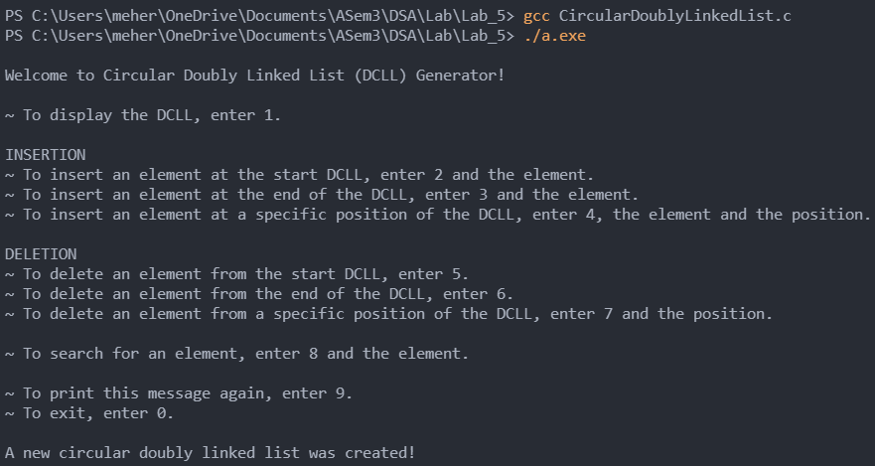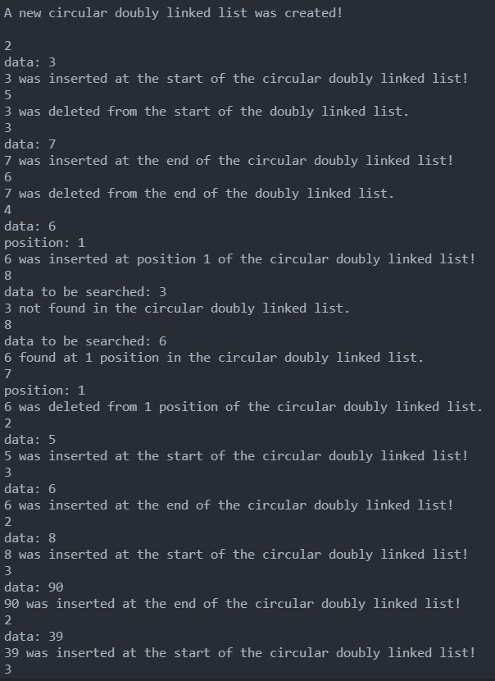

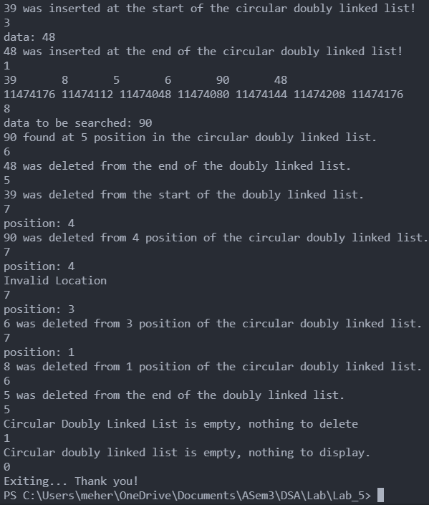

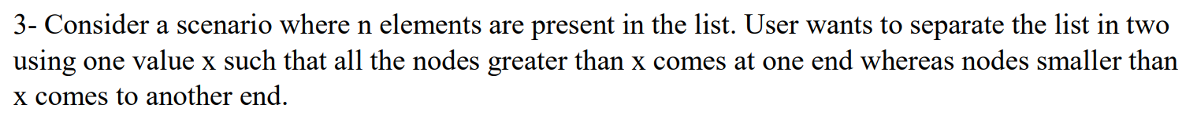

**CODE FOR NODE SEPARATION:**

**Code is same as doubly linked list code, and has separateByX function at the end –**

*// NodeSeparation.c*

#include <stdio.h>

#include <stdlib.h>

#include <limits.h>

*/*  Question -*

*\*   Consider a scenario where n elements are present in the list. User wants to separate the list in two*

*\*   using one value x such that all the nodes greater than x comes at one end whereas nodes smaller than*

*\*   x comes to another end*

*\*/*

*/*  Soultion -*

*\*   Here the question is solved for doubly linked lists.*

*\*   We traverse through the linked list. If we come across a node that is greater than x, it is moved to*

*\*   front of the linked list. The nodes less than x will automatically end up towards the end.*

*\*   Here we have to keep in mind to move the node itself, we are not creating a newnode with the same*

*\*   data and moving it in the front, we are changing the place of the node in the list.*

*\**

*\*   Refer to the doubly linked list program (DoublyLinkedList.c).*

*\**

*\**

*\*/*

typedef struct Node{

    int data;

    struct Node * prev;

    struct Node * next;

}Node;

typedef struct DoublyLinkedList

{

    Node * start;

    int len;

}DoublyLinkedList;

Node * createNode(int *item*)

{

    Node * temp = (Node *)malloc(sizeof(Node));

    temp->data = *item*;

    temp->next = NULL;

    temp->prev = NULL;

    return temp;

}

DoublyLinkedList * createDoublyLinkedList()

{

    DoublyLinkedList * dll = (DoublyLinkedList *)malloc(sizeof(DoublyLinkedList));

    dll->len = 0;

    dll->start = (Node *)malloc(sizeof(Node));

    dll->start->data = INT_MIN; *// Data in the start node is never to be accessed. If INT_MIN is the data displayed, an error has possibly occured*

    dll->start->next = NULL;

    dll->start->prev = NULL;

    printf("A new doubly linked list was created!\n");

    return dll;

}

*/* Insertion */*

*// Inserts an element at the start of a linked list*

void insertAtStart(DoublyLinkedList * *dll*, int *item*)

{

    Node * newnode = createNode(*item*);

    if(*dll*->start->next != NULL)

    {

        newnode->next = *dll*->start->next;

*dll*->start->next->prev = newnode;

    }

*dll*->start->next = newnode;

    printf("%d was inserted at the start of the doubly linked list!\n", *item*);

*dll*->len++;

}

*// Inserts an element at the end of a doubly linked list*

void insertAtEnd(DoublyLinkedList * *dll*, int *item*)

{

    Node * newnode = createNode(*item*);

    Node * ptr = *dll*->start;

    while(ptr->next != NULL)

        ptr = ptr->next;

    ptr->next = newnode;

    if(ptr != *dll*->start)

        newnode->prev = ptr;

    printf("%d was inserted at the end of the doubly linked list!\n", *item*);

*dll*->len++;

}

*// Inserts an element at a specified position.*

*// Here, position is determined by usual 1-base counting. If position = 5, item will be the fifth element in the linked list*

void insertAtPosition(DoublyLinkedList * *dll*, int *item*, int *position*)

{

    Node * newnode = createNode(*item*);

    Node * ptr = *dll*->start;

    for(int i = 0; i < (*position* - 1); i++)

    {

        if(ptr->next == NULL && i + 1 < *position*)

        {

            printf("Invalid Location\n");

            return;

        }

        ptr = ptr->next;

    }

    if(*position* != 1) *// If adding at beginning then newnode's prev will remain NULL*

        newnode->prev = ptr;

    if(*dll*->start->next != NULL) *// When list is not empty*

    {

        newnode->next = ptr->next;

        if(ptr->next != NULL)

            ptr->next->prev = newnode; *// Skip this if adding at the end*

    }

    ptr->next = newnode;

    printf("%d was inserted at position %d of the doubly linked list!\n", *item*, *position*);

*dll*->len++;

}

*/* Traversal */*

*/* Display function provided for illustrative purposes.*/*

void display(DoublyLinkedList * *dll*)

{

    if(*dll*->start->next == NULL)

    {

        printf("Empty Doubly Linked List, nothing to display.\n");

        return;

    }

*// Printing data*

    Node * ptr = *dll*->start->next;

    printf("Start: %d \n", *dll*->start);

    while(ptr != NULL)

    {

        printf("%d       ", ptr->data);

        ptr = ptr->next;

    }

*// Printing the location*

    Node * ptr2 = *dll*->start->next;

    printf("\n%d ", *dll*->start->next);

    while(ptr2 != NULL)

    {

        printf("%d ", ptr2->next);

        ptr2 = ptr2->next;

    }

    printf("\n");

}

*// Returns the 1-base position of the first occurance of data.*

int search(DoublyLinkedList * *dll*, int *item*)

{

    if(*dll*->start->next == NULL)

    {

        printf("Empty Doubly Linked List, nothing to search for.\n");

        return INT_MIN;

    }

    int count = 1;

    Node * ptr = *dll*->start->next;

    while(ptr->data != *item*)

    {

        if(ptr->data != *item* && ptr->next == NULL)

        {

            printf("%d not found in the doubly linked list.\n", *item*);

            return INT_MIN;

        }

        ptr = ptr->next;

        count++;

    }

    printf("%d found at %d position in the doubly linked list.\n", *item*, count);

    return count;

}

*/* Deletion */*

*// Deletion at start*

int deleteAtStart(DoublyLinkedList * *dll*)

{

    if(*dll*->start->next == NULL)

    {

        printf("Doubly Linked List is empty, nothing to delete.\n");

        return INT_MIN;

    }

    Node * ptr = *dll*->start->next;

*dll*->start->next = ptr->next;

    if(ptr->next != NULL)

        ptr->next->prev = NULL;

    int data = ptr->data;

    free(ptr);

    printf("%d was deleted from the start of the doubly linked list.\n", data);

*dll*->len--;

    return data;

}

*// Deletion at end*

int deleteAtEnd(DoublyLinkedList * *dll*)

{

    if(*dll*->start->next == NULL)

    {

        printf("Doubly Linked List is empty, nothing to delete\n");

        return INT_MIN;

    }

    int data;

    Node * ptr = *dll*->start->next;

    while(ptr->next != NULL)

        ptr = ptr->next;

    if(ptr->prev == NULL) *// Only one element is present*

*dll*->start->next = NULL;

    else *// Other cases*

        ptr->prev->next = NULL;

    data = ptr->data;

    free(ptr);

*dll*->len--;

    printf("%d was deleted from the start of the doubly linked list.\n", data);

    return data;

}

*// Deletion of an element at a particular position*

*// Here, position is determined by usual 1-base counting.*

int deleteAtPosition(DoublyLinkedList * *dll*, int *position*)

{

    if(*dll*->start->next == NULL)

    {

        printf("Doubly Linked List is empty, nothing to delete\n");

        return INT_MIN;

    }

    Node * ptr = *dll*->start;

    int data;

    for(int i = 0; i < *position*; i++)

    {

        if(ptr->next == NULL && i < *position*)

        {

            printf("Invalid Location\n");

            return INT_MIN;

        }

        ptr = ptr->next;

    }

    if(ptr->prev == NULL) *// If first element is to be deleted*

*dll*->start->next = ptr->next;

    else

        ptr->prev->next = ptr->next;

    if(ptr->next != NULL)

        ptr->next->prev = ptr->prev;

    data = ptr->data;

    free(ptr);

*dll*->len--;

    printf("%d was deleted from %d position of the doubly linked list.\n", data, *position*);

    return data;

}

void separateByX(DoublyLinkedList * *dll*, int *x*)

{

    printf("Separating Nodes by %d\n", *x*);

    Node * ptr = *dll*->start->next;

    Node * ptr1;

    while(ptr != NULL)

    {

        ptr1 = ptr->next;

        if(ptr->data > *x*)

        {

            if(ptr->prev != NULL)

            {

                ptr->prev->next = ptr->next;

                ptr->next->prev = ptr->prev;

                ptr->next = *dll*->start->next;

                ptr->prev = NULL;

*dll*->start->next->prev = ptr;

*dll*->start->next = ptr;

            }

        }

        ptr = ptr1;

    }

}

int main()

{

    DoublyLinkedList * dll = createDoublyLinkedList();

    insertAtEnd(dll, 30);

    insertAtEnd(dll, 25);

    insertAtEnd(dll, 65);

    insertAtEnd(dll, 20);

    insertAtEnd(dll, 5);

    insertAtEnd(dll, 75);

    insertAtEnd(dll, 10);

    insertAtEnd(dll, 20);

    display(dll);

    separateByX(dll, 25);

    display(dll);

}

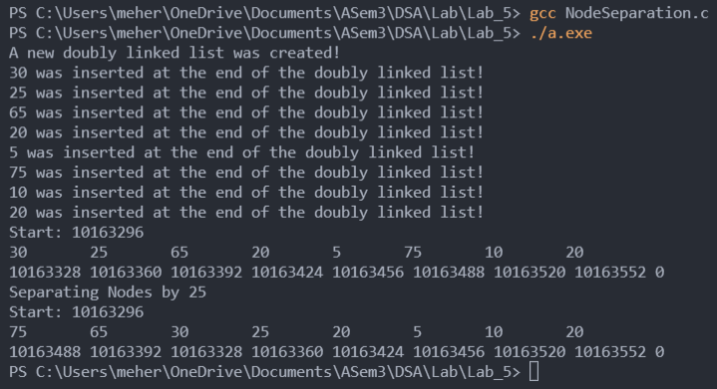



**CODE FOR MERGING DOUBLY LINKED LISTS:**

**Code is same as doubly linked list code, and has join function at the end –**

*// MergeDoublyLinkedList.c*

#include <stdio.h>

#include <stdlib.h>

#include <limits.h>

*/*  Question -*

*\*   Consider one scenario where two lists is given and needs to be merged in a single list. Write a*

*\*   program for the given scenario.*

*\*/*

*/*  Soultion -*

*\*   We join the last element to the first element of the second list and delete the second list's start.*

*\*   Refer to the doubly linked list program (DoublyLinkedList.c).*

*\**

*\**

*\*/*

typedef struct Node{

    int data;

    struct Node * prev;

    struct Node * next;

}Node;

typedef struct DoublyLinkedList

{

    Node * start;

    int len;

}DoublyLinkedList;

Node * createNode(int *item*)

{

    Node * temp = (Node *)malloc(sizeof(Node));

    temp->data = *item*;

    temp->next = NULL;

    temp->prev = NULL;

    return temp;

}

DoublyLinkedList * createDoublyLinkedList()

{

    DoublyLinkedList * dll = (DoublyLinkedList *)malloc(sizeof(DoublyLinkedList));

    dll->len = 0;

    dll->start = (Node *)malloc(sizeof(Node));

    dll->start->data = INT_MIN; *// Data in the start node is never to be accessed. If INT_MIN is the data displayed, an error has possibly occured*

    dll->start->next = NULL;

    dll->start->prev = NULL;

    printf("A new doubly linked list was created!\n");

    return dll;

}

*/* Insertion */*

*// Inserts an element at the start of a linked list*

void insertAtStart(DoublyLinkedList * *dll*, int *item*)

{

    Node * newnode = createNode(*item*);

    if(*dll*->start->next != NULL)

    {

        newnode->next = *dll*->start->next;

*dll*->start->next->prev = newnode;

    }

*dll*->start->next = newnode;

    printf("%d was inserted at the start of the doubly linked list!\n", *item*);

*dll*->len++;

}

*// Inserts an element at the end of a doubly linked list*

void insertAtEnd(DoublyLinkedList * *dll*, int *item*)

{

    Node * newnode = createNode(*item*);

    Node * ptr = *dll*->start;

    while(ptr->next != NULL)

        ptr = ptr->next;

    ptr->next = newnode;

    if(ptr != *dll*->start)

        newnode->prev = ptr;

    printf("%d was inserted at the end of the doubly linked list!\n", *item*);

*dll*->len++;

}

*// Inserts an element at a specified position.*

*// Here, position is determined by usual 1-base counting. If position = 5, item will be the fifth element in the linked list*

void insertAtPosition(DoublyLinkedList * *dll*, int *item*, int *position*)

{

    Node * newnode = createNode(*item*);

    Node * ptr = *dll*->start;

    for(int i = 0; i < (*position* - 1); i++)

    {

        if(ptr->next == NULL && i + 1 < *position*)

        {

            printf("Invalid Location\n");

            return;

        }

        ptr = ptr->next;

    }

    if(*position* != 1) *// If adding at beginning then newnode's prev will remain NULL*

        newnode->prev = ptr;

    if(*dll*->start->next != NULL) *// When list is not empty*

    {

        newnode->next = ptr->next;

        if(ptr->next != NULL)

            ptr->next->prev = newnode; *// Skip this if adding at the end*

    }

    ptr->next = newnode;

    printf("%d was inserted at position %d of the doubly linked list!\n", *item*, *position*);

*dll*->len++;

}

*/* Traversal */*

*/* Display function provided for illustrative purposes.*/*

void display(DoublyLinkedList * *dll*)

{

    if(*dll*->start->next == NULL)

    {

        printf("Empty Doubly Linked List, nothing to display.\n");

        return;

    }

*// Printing data*

    Node * ptr = *dll*->start->next;

    printf("Start: %d \n", *dll*->start);

    while(ptr != NULL)

    {

        printf("%d       ", ptr->data);

        ptr = ptr->next;

    }

*// Printing the location*

    Node * ptr2 = *dll*->start->next;

    printf("\n%d ", *dll*->start->next);

    while(ptr2 != NULL)

    {

        printf("%d ", ptr2->next);

        ptr2 = ptr2->next;

    }

    printf("\n");

}

*// Returns the 1-base position of the first occurance of data.*

int search(DoublyLinkedList * *dll*, int *item*)

{

    if(*dll*->start->next == NULL)

    {

        printf("Empty Doubly Linked List, nothing to search for.\n");

        return INT_MIN;

    }

    int count = 1;

    Node * ptr = *dll*->start->next;

    while(ptr->data != *item*)

    {

        if(ptr->data != *item* && ptr->next == NULL)

        {

            printf("%d not found in the doubly linked list.\n", *item*);

            return INT_MIN;

        }

        ptr = ptr->next;

        count++;

    }

    printf("%d found at %d position in the doubly linked list.\n", *item*, count);

    return count;

}

*/* Deletion */*

*// Deletion at start*

int deleteAtStart(DoublyLinkedList * *dll*)

{

    if(*dll*->start->next == NULL)

    {

        printf("Doubly Linked List is empty, nothing to delete.\n");

        return INT_MIN;

    }

    Node * ptr = *dll*->start->next;

*dll*->start->next = ptr->next;

    if(ptr->next != NULL)

        ptr->next->prev = NULL;

    int data = ptr->data;

    free(ptr);

    printf("%d was deleted from the start of the doubly linked list.\n", data);

*dll*->len--;

    return data;

}

*// Deletion at end*

int deleteAtEnd(DoublyLinkedList * *dll*)

{

    if(*dll*->start->next == NULL)

    {

        printf("Doubly Linked List is empty, nothing to delete\n");

        return INT_MIN;

    }

    int data;

    Node * ptr = *dll*->start->next;

    while(ptr->next != NULL)

        ptr = ptr->next;

    if(ptr->prev == NULL) *// Only one element is present*

*dll*->start->next = NULL;

    else *// Other cases*

        ptr->prev->next = NULL;

    data = ptr->data;

    free(ptr);

*dll*->len--;

    printf("%d was deleted from the start of the doubly linked list.\n", data);

    return data;

}

*// Deletion of an element at a particular position*

*// Here, position is determined by usual 1-base counting.*

int deleteAtPosition(DoublyLinkedList * *dll*, int *position*)

{

    if(*dll*->start->next == NULL)

    {

        printf("Doubly Linked List is empty, nothing to delete\n");

        return INT_MIN;

    }

    Node * ptr = *dll*->start;

    int data;

    for(int i = 0; i < *position*; i++)

    {

        if(ptr->next == NULL && i < *position*)

        {

            printf("Invalid Location\n");

            return INT_MIN;

        }

        ptr = ptr->next;

    }

    if(ptr->prev == NULL) *// If first element is to be deleted*

*dll*->start->next = ptr->next;

    else

        ptr->prev->next = ptr->next;

    if(ptr->next != NULL)

        ptr->next->prev = ptr->prev;

    data = ptr->data;

    free(ptr);

*dll*->len--;

    printf("%d was deleted from %d position of the doubly linked list.\n", data, *position*);

    return data;

}

*// Join two doubly linked lists*

void joinDoublyLinkedLists(DoublyLinkedList * *dll1*, DoublyLinkedList * *dll2*)

{

    printf("Joining doubly linked lists...\n");

    Node * ptr = *dll1*->start;

    while(ptr->next != NULL)

        ptr = ptr->next;

    ptr->next = *dll2*->start->next;

*dll2*->start->next->prev = ptr;

    free(*dll2*->start);

    free(*dll2*);

}

int main()

{

    DoublyLinkedList * dll = createDoublyLinkedList();

    insertAtEnd(dll, 30);

    insertAtEnd(dll, 25);

    insertAtEnd(dll, 65);

    insertAtEnd(dll, 20);

    insertAtEnd(dll, 5);

    insertAtEnd(dll, 75);

    insertAtEnd(dll, 10);

    insertAtEnd(dll, 20);

    display(dll);

    DoublyLinkedList * dll1 = createDoublyLinkedList();

    insertAtEnd(dll1, 20);

    insertAtEnd(dll1, 85);

    insertAtEnd(dll1, 61);

    insertAtEnd(dll1, 20);

    insertAtEnd(dll1, 56);

    insertAtEnd(dll1, 75);

    insertAtEnd(dll1, 17);

    insertAtEnd(dll1, 90);

    display(dll1);

    joinDoublyLinkedLists(dll, dll1);

    display(dll);

}

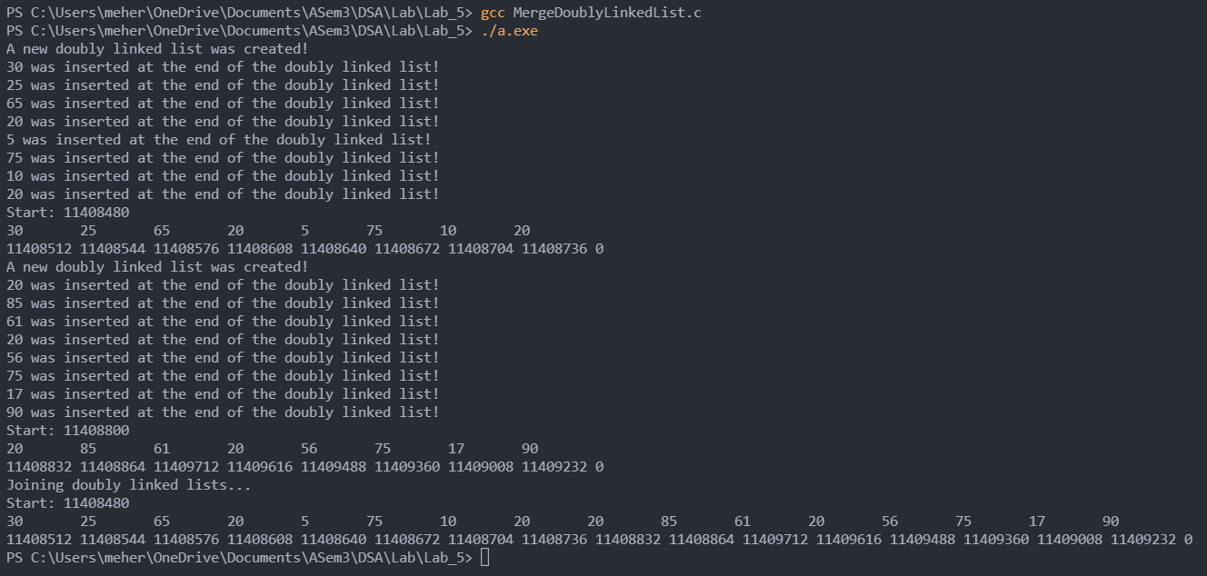



**CODE FOR REVERSING DOUBLY LINKED LISTS:**

**Code is same as reversing linked list code, and has reverse functions at the end(iterative method and recursive method) –**

*// ReverseDoublyLinkedList.c*

#include <stdio.h>

#include <stdlib.h>

#include <limits.h>

*/*  Question -*

*\*   There are few elements is given in the list. Given elements are not in a sorted way. Write one*

*\*   function to reverse the given list (using recursion and without using recursion)*

*\*/*

typedef struct Node{

    int data;

    struct Node * prev;

    struct Node * next;

}Node;

typedef struct DoublyLinkedList

{

    Node * start;

    int len;

}DoublyLinkedList;

Node * createNode(int *item*)

{

    Node * temp = (Node *)malloc(sizeof(Node));

    temp->data = *item*;

    temp->next = NULL;

    temp->prev = NULL;

    return temp;

}

DoublyLinkedList * createDoublyLinkedList()

{

    DoublyLinkedList * dll = (DoublyLinkedList *)malloc(sizeof(DoublyLinkedList));

    dll->len = 0;

    dll->start = (Node *)malloc(sizeof(Node));

    dll->start->data = INT_MIN; *// Data in the start node is never to be accessed. If INT_MIN is the data displayed, an error has possibly occured*

    dll->start->next = NULL;

    dll->start->prev = NULL;

    printf("A new doubly linked list was created!\n");

    return dll;

}

*/* Insertion */*

*// Inserts an element at the start of a linked list*

void insertAtStart(DoublyLinkedList * *dll*, int *item*)

{

    Node * newnode = createNode(*item*);

    if(*dll*->start->next != NULL)

    {

        newnode->next = *dll*->start->next;

*dll*->start->next->prev = newnode;

    }

*dll*->start->next = newnode;

    printf("%d was inserted at the start of the doubly linked list!\n", *item*);

*dll*->len++;

}

*// Inserts an element at the end of a doubly linked list*

void insertAtEnd(DoublyLinkedList * *dll*, int *item*)

{

    Node * newnode = createNode(*item*);

    Node * ptr = *dll*->start;

    while(ptr->next != NULL)

        ptr = ptr->next;

    ptr->next = newnode;

    if(ptr != *dll*->start)

        newnode->prev = ptr;

    printf("%d was inserted at the end of the doubly linked list!\n", *item*);

*dll*->len++;

}

*// Inserts an element at a specified position.*

*// Here, position is determined by usual 1-base counting. If position = 5, item will be the fifth element in the linked list*

void insertAtPosition(DoublyLinkedList * *dll*, int *item*, int *position*)

{

    Node * newnode = createNode(*item*);

    Node * ptr = *dll*->start;

    for(int i = 0; i < (*position* - 1); i++)

    {

        if(ptr->next == NULL && i + 1 < *position*)

        {

            printf("Invalid Location\n");

            return;

        }

        ptr = ptr->next;

    }

    if(*position* != 1) *// If adding at beginning then newnode's prev will remain NULL*

        newnode->prev = ptr;

    if(*dll*->start->next != NULL) *// When list is not empty*

    {

        newnode->next = ptr->next;

        if(ptr->next != NULL)

            ptr->next->prev = newnode; *// Skip this if adding at the end*

    }

    ptr->next = newnode;

    printf("%d was inserted at position %d of the doubly linked list!\n", *item*, *position*);

*dll*->len++;

}

*/* Traversal */*

*/* Display function provided for illustrative purposes.*/*

void display(DoublyLinkedList * *dll*)

{

    if(*dll*->start->next == NULL)

    {

        printf("Empty Doubly Linked List, nothing to display.\n");

        return;

    }

*// Printing data*

    Node * ptr = *dll*->start->next;

    printf("Start: %d \n", *dll*->start);

    while(ptr != NULL)

    {

        printf("%d       ", ptr->data);

        ptr = ptr->next;

    }

*// Printing the location*

    Node * ptr2 = *dll*->start->next;

    printf("\n%d ", *dll*->start->next);

    while(ptr2 != NULL)

    {

        printf("%d ", ptr2->next);

        ptr2 = ptr2->next;

    }

    printf("\n");

}

*// Returns the 1-base position of the first occurance of data.*

int search(DoublyLinkedList * *dll*, int *item*)

{

    if(*dll*->start->next == NULL)

    {

        printf("Empty Doubly Linked List, nothing to search for.\n");

        return INT_MIN;

    }

    int count = 1;

    Node * ptr = *dll*->start->next;

    while(ptr->data != *item*)

    {

        if(ptr->data != *item* && ptr->next == NULL)

        {

            printf("%d not found in the doubly linked list.\n", *item*);

            return INT_MIN;

        }

        ptr = ptr->next;

        count++;

    }

    printf("%d found at %d position in the doubly linked list.\n", *item*, count);

    return count;

}

*/* Deletion */*

*// Deletion at start*

int deleteAtStart(DoublyLinkedList * *dll*)

{

    if(*dll*->start->next == NULL)

    {

        printf("Doubly Linked List is empty, nothing to delete.\n");

        return INT_MIN;

    }

    Node * ptr = *dll*->start->next;

*dll*->start->next = ptr->next;

    if(ptr->next != NULL)

        ptr->next->prev = NULL;

    int data = ptr->data;

    free(ptr);

    printf("%d was deleted from the start of the doubly linked list.\n", data);

*dll*->len--;

    return data;

}

*// Deletion at end*

int deleteAtEnd(DoublyLinkedList * *dll*)

{

    if(*dll*->start->next == NULL)

    {

        printf("Doubly Linked List is empty, nothing to delete\n");

        return INT_MIN;

    }

    int data;

    Node * ptr = *dll*->start->next;

    while(ptr->next != NULL)

        ptr = ptr->next;

    if(ptr->prev == NULL) *// Only one element is present*

*dll*->start->next = NULL;

    else *// Other cases*

        ptr->prev->next = NULL;

    data = ptr->data;

    free(ptr);

*dll*->len--;

    printf("%d was deleted from the start of the doubly linked list.\n", data);

    return data;

}

*// Deletion of an element at a particular position*

*// Here, position is determined by usual 1-base counting.*

int deleteAtPosition(DoublyLinkedList * *dll*, int *position*)

{

    if(*dll*->start->next == NULL)

    {

        printf("Doubly Linked List is empty, nothing to delete\n");

        return INT_MIN;

    }

    Node * ptr = *dll*->start;

    int data;

    for(int i = 0; i < *position*; i++)

    {

        if(ptr->next == NULL && i < *position*)

        {

            printf("Invalid Location\n");

            return INT_MIN;

        }

        ptr = ptr->next;

    }

    if(ptr->prev == NULL) *// If first element is to be deleted*

*dll*->start->next = ptr->next;

    else

        ptr->prev->next = ptr->next;

    if(ptr->next != NULL)

        ptr->next->prev = ptr->prev;

    data = ptr->data;

    free(ptr);

*dll*->len--;

    printf("%d was deleted from %d position of the doubly linked list.\n", data, *position*);

    return data;

}

*// Reverse a doubly linked list by iterative method*

void reverse_1(DoublyLinkedList * *dll*)

{

    printf("Reversing doubly linked list by iterative method\n");

    Node * ptr = *dll*->start->next->next;

    Node * ptr1;

    while(ptr != NULL)

    {

        ptr1 = ptr->next;

        if(ptr->prev != NULL)

        {

            ptr->prev->next = ptr->next;

            if(ptr->next != NULL)

                ptr->next->prev = ptr->prev;

            ptr->next = *dll*->start->next;

            ptr->prev = NULL;

*dll*->start->next->prev = ptr;

*dll*->start->next = ptr;

        }

        ptr = ptr1;

    }

}

*// Reverse a doubly linked list with recursion*

void reverse_2(Node * *ptr*, Node * *start*)

{

    if(*ptr*->next == NULL)

    {

        printf("Reversing doubly linked list using recursion\n");

*start*->next = *ptr*;

        return;

    }

    reverse_2(*ptr*->next, *start*);

*ptr*->next->prev = *ptr*->next->next;

*ptr*->next->next = *ptr*;

    if(*ptr*->prev == NULL)

    {

*ptr*->prev = *ptr*->next;

*ptr*->next = NULL;

    }

}

int main()

{

    DoublyLinkedList * dll = createDoublyLinkedList();

    insertAtEnd(dll, 30);

    insertAtEnd(dll, 25);

    insertAtEnd(dll, 65);

    insertAtEnd(dll, 20);

    insertAtEnd(dll, 57);

    insertAtEnd(dll, 75);

    insertAtEnd(dll, 10);

    insertAtEnd(dll, 29);

    display(dll);

*// Reversing using iterative method*

    reverse_1(dll);

    display(dll);

*// Reversing using recursive method*

    reverse_2(dll->start->next, dll->start);

    display(dll);

}

